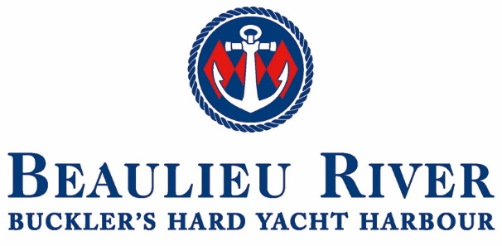
JOB DESCRIPTION

Job Title: Dock Master, Beaulieu River

Hours: Full Time – 37.5 hours
Working a shift pattern 4 days on, 4 days off
Hours 12.30 to 23.30

Employer: Beaulieu Enterprises Ltd

Reporting to: Deputy Harbour Master

Overall: To patrol the Beaulieu River to ensure that the river operates as efficiently and safely as possible in accordance with the Port Marine Safety Code

To provide the highest level of customer service when managing enquiries and taking bookings from existing and prospective customers. Liaising with and assisting the Harbour Master and Deputy in their duties.

The role will require lone working during evening hours and you will be responsible for the security of the site during these times.

Key Duties:

- To patrol the Beaulieu River to ensure that the harbour operates as efficiently and safely as possible in accordance with the Port Marine Safety Code.
- To carry out responsibilities as per the Port Marine Safety Code and keep accurate records.
- To ensure the highest standards of service to customers, protecting the reputation of the company at all times.
- To manage the daily berthing of visitors and ensure they are berthed in a manner that optimises the total capacity.
- To respond to customer complaints in a professional manner in the first instance.
- To work with river users and boat owners to manage and conserve the river and river environs by providing education and understanding of the objectives and policies.
- To undertake the daily supervision of River Hands
- Collect Harbour Dues from the marina and river and sell fuel and money is balanced at the end of the day, although with the new online payment system this will be limited but will require adhoc checking of receipts.
- Ensure customer data is inputted and updated on Harbour Assist as and when required.
- To assist in the maintenance of all company boats ensuring they are in a safe and effective conditions.
- To assist in the general maintenance of the marina, river and fuel pumps.
- To operate and maintain the 40’ barge for servicing moorings and other work as required.
- Ensure all slipways are cleaned and ready to use.
- Assist with the training of all seasonal river hands.
- To maintain, repair and servicing of all mooring tackle as required.
- To operate the CCTV
- To patrol other site areas as directed by the Deputy Harbour Master.
- To ensure that all buildings are secure and to maintain vigilance at all times.
- To set Alarm systems as directed and to report any malfunctions.
- To ensure that all buildings and public areas are safe from fire.
- Carry out regular inspections of car parks, skip compound and toilets.
- To notify the Deputy Harbour Master of any incidents, maintenance requirements as and when required.
- To carry out all duties in a way which will ensure the Health and Safety of staff and visitors is adhered to.
- To undertake any other duties as required by the Harbour Master or Deputy Harbour Master and when necessary to stand-in for other members of staff to the best of their ability which includes assisting in the boatyard and chandlery.

Person Specification

Essential

RYA Powerboat Level 2
VHF Short Range Radio Licence
Excellent Customer Care Skills
Physical Fitness and ability to undertake outdoor physical work
Able to swim
Basic Clerical and keyboard skills
Cash handling
Ability to work unsupervised
Ability to communicate tactfully and diplomatically at all levels

Desirable
Experience working in the marine industry
Boat Handling including towing
First Aid at Sea
Experience of CCTV operation

A flexible approach towards working times is required, working a rotating roster, including bank holidays and weekends. At times, it will be required to work additional hours during peak busy periods or special events and is on call in times of an emergency or bad weather.

Last reviewed 18/7/25 WS & LG

